BATCH ID: B5-5M1E

ROLL NO: CITC1904073

NAME: DHARANI K

CODE:

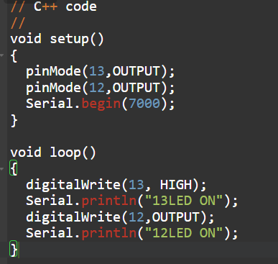

SIMULATION:

